Dataset Link: <https://drive.google.com/file/d/1jDcs1bMKwxgpFMQqWDmC1DP2hVI-Jt1s/view?usp=sharing>

Task to be performed :

1. Import the database mentioned above and implement the following manipulative task .
2. Compute the count of houses having price greater than 1 Million?
3. Extract the house having council area starting with port?
4. Fetch the Address of the house having more than 3 rooms and 2 bedroom?
5. How many houses are lying in postal code 3042?
6. Extract house build in 2005 having 1 car and 2 Bedroom?
7. How many houses built in suburb albert park built before 2000?
8. Compute the count of houses built in Caulfield Southbefore 1950 and cost more than 10 Million?
9. Extract the records with houses having land size more than 400 and cost less than 12 Million?
10. What is the average cost of house in Yarra having more than 3 rooms ?
11. Extract the suburb having the costliest house?
12. Extract the postal code with the cheapest house?
13. Compute the count of house lying in Darebin region having 2 cars?

|  |
| --- |

1. Average price of houses selled by Buxton?
2. Sellers with Maximun houses?
3. Create table as salesman:

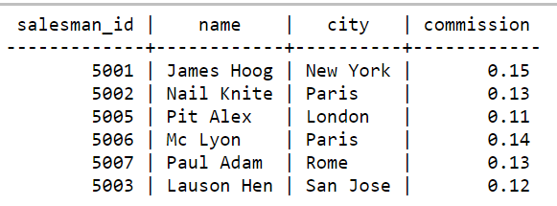

17 Create table as customer:

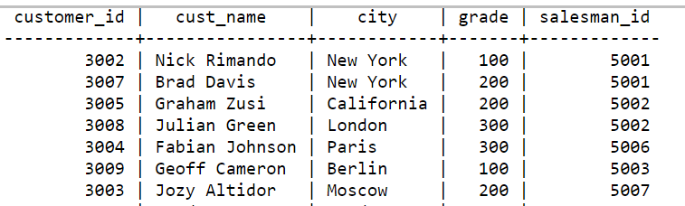

Performs the set of queries for the same :

From the following tables write a SQL query to find the salesperson and customer who reside in the same city. Return Salesman, cust_name and city.

|  |
| --- |